NR exempted from filing Form 10F

F. No. DGIT(S)-ADG(S)-3/e-Filing

New Delhi, December 12, 2022
Keeping in mind the hardships faced by non-resident taxpayers who neither have a PAN nor are required to obtain one as per the provisions of the Income Tax Act, the CBDT has exempted this category of non-residents from e-filing Form 10F till March 31, 2023. However, the non-resident may continue with the Manual filing as was directed before the issuance of Notification 3 of 2022.

*Form 10F provides details on behalf of such non-residents who neither have a PAN nor a Tax Residency Certificate (TRC). TRC confirms the residency of the respective country in cases of foreign-country transactions. To avail the benefit of DTAA,
- Tax Residency Certificate (TRC),
- Form 10F, and
- no-permanent establishment (PE) certificate
are the 3 major requirements that are to be produced by the Non-residents. It facilitates the non-resident to take advantage of a lower withholding rate or DTAA benefit pursuant to the production of necessary documents.
*Notification 3 of 2022 mandated the online filing of Form 10F post-March 2022 with respect to non-residents.
1

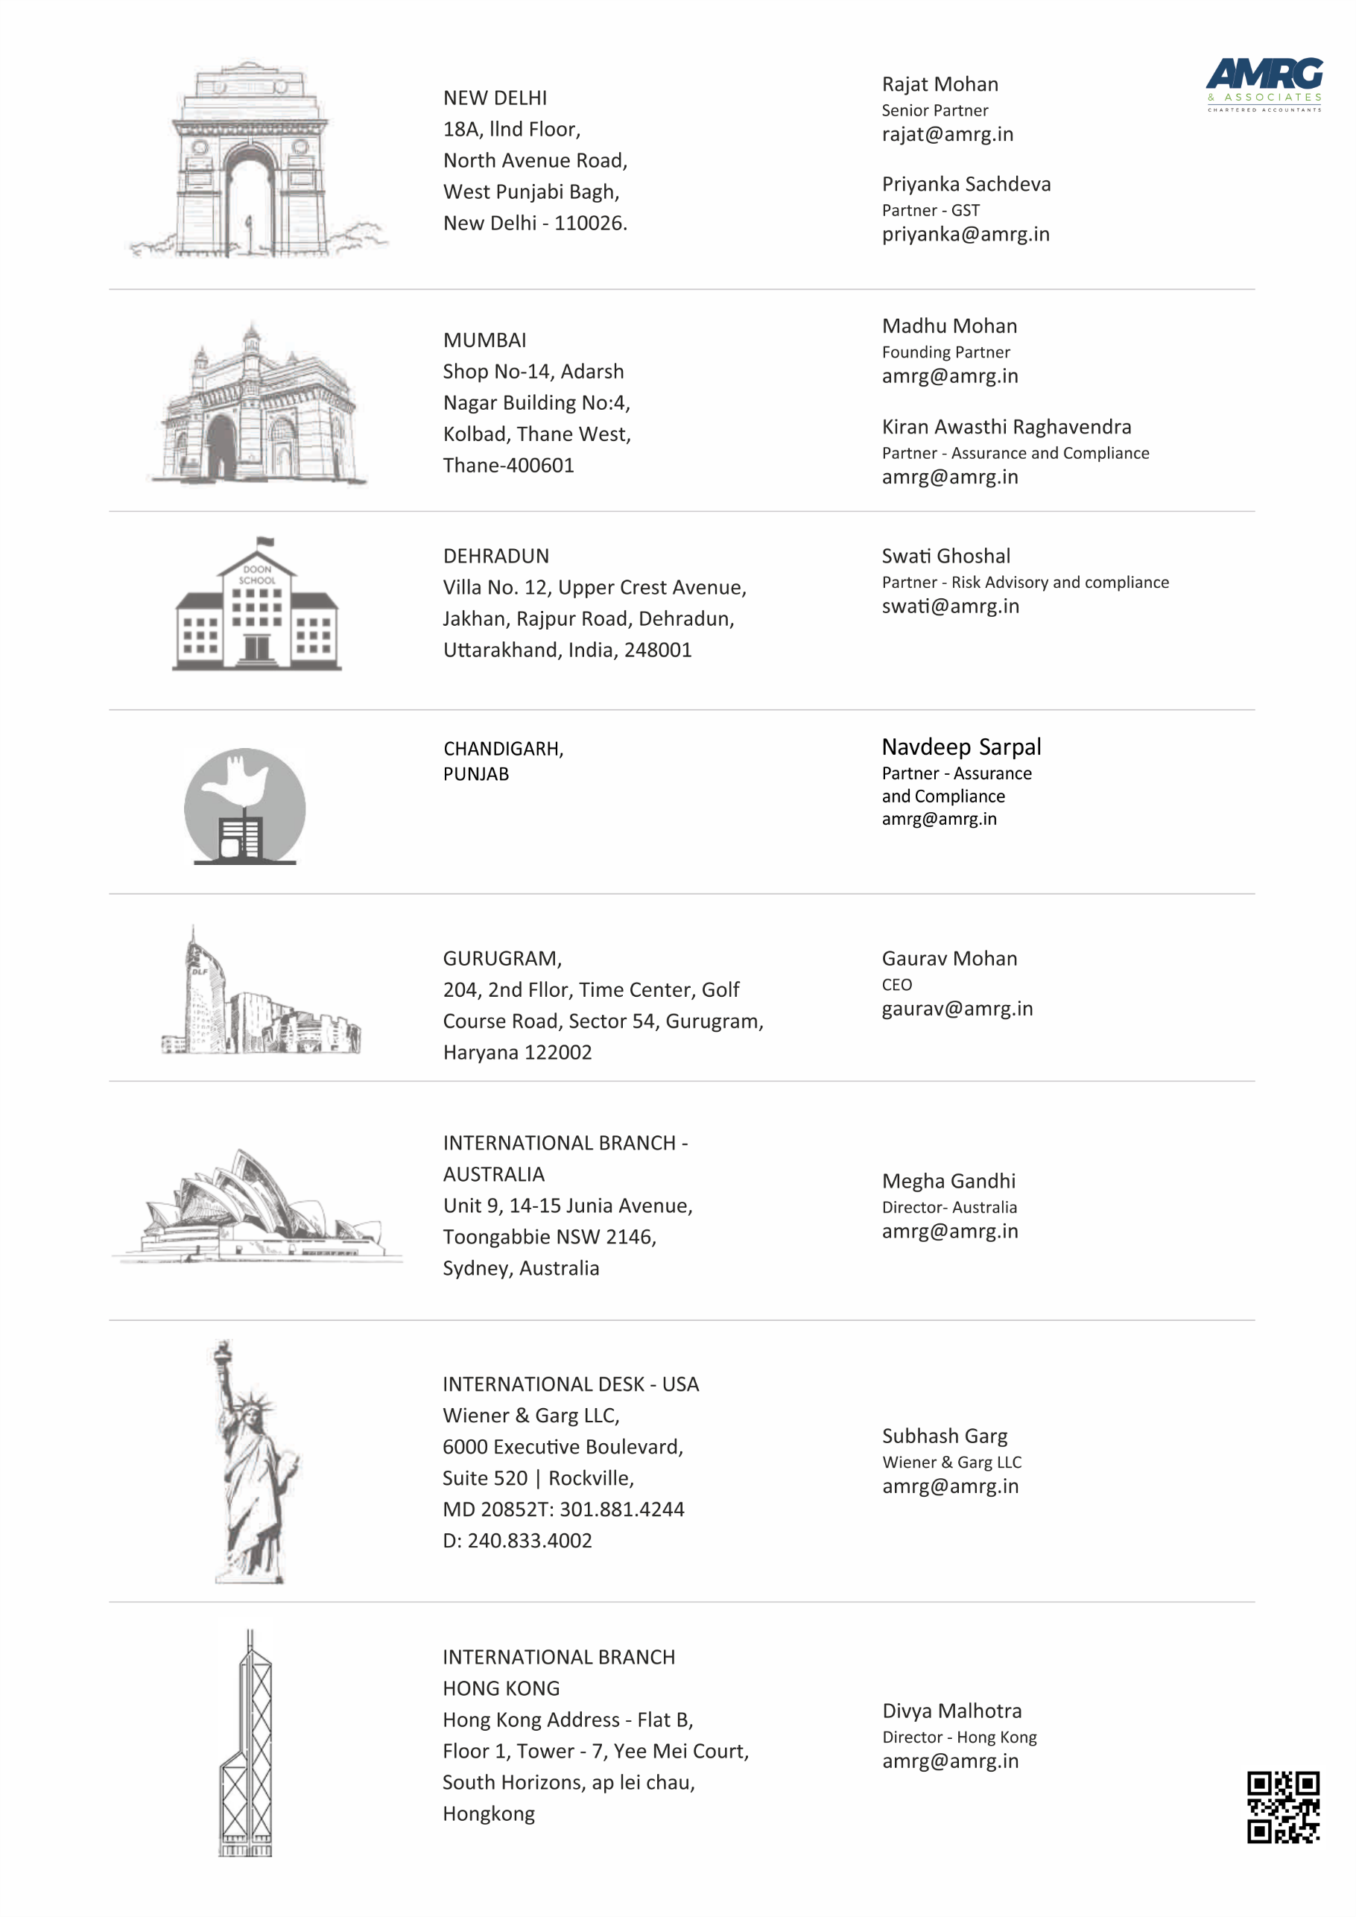
Sit conder leveySit conder levey0

